## # TA_AI_Edit

AI editor main directory, which mainly contains

**MainUi.exe（main program）**

**ta_config.properties（configuration file）**

## # About

Main Page

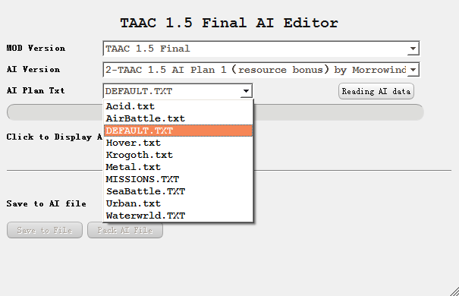

Reading AI Data and Click Limit or Weight

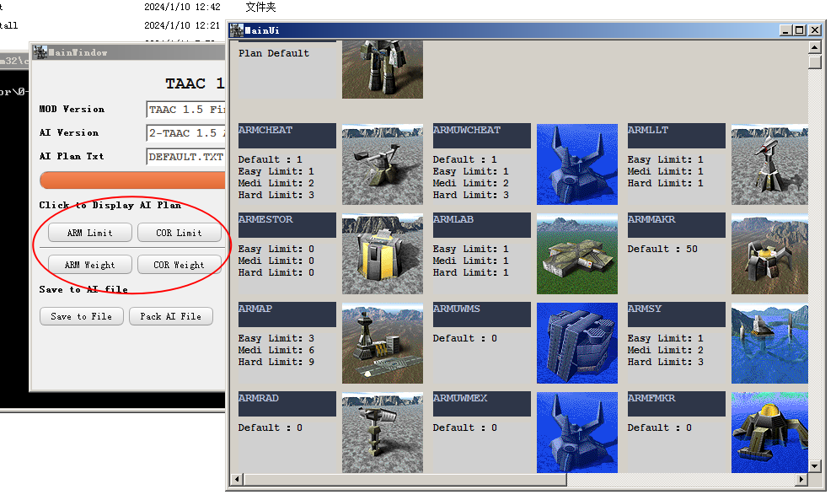

Show Tech And Build List.

Limit Controls how many unit AI builds

Weight Controls how high priority unit AI builds

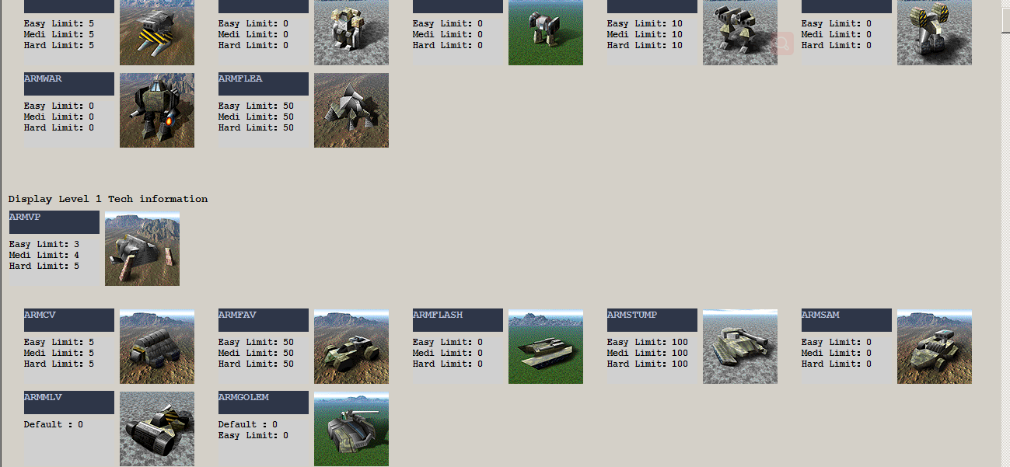

Easy Medium Hard each means AI difficult Level.

**Default means for ALL Difficult Level,It is the Highest priority.**

Blank means there is no data in Plan, and AI usualy will not build it.

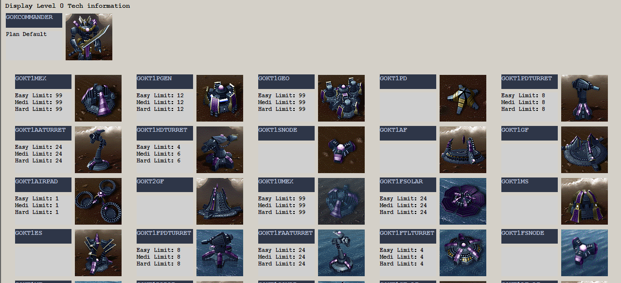

Click the icon will pop up the Unit Detail page, here you can set the Limit and Weight.

The suggestion of Weight is within the range of 0-9, too high will cause AI stupid.

Click to save will delete the default data

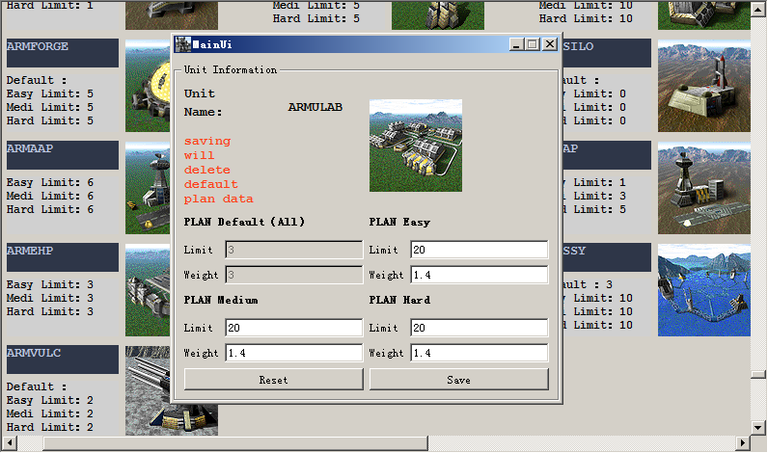

When you have make yourself AI plan, you can click save to file.

And click ok to replace the old AI file.

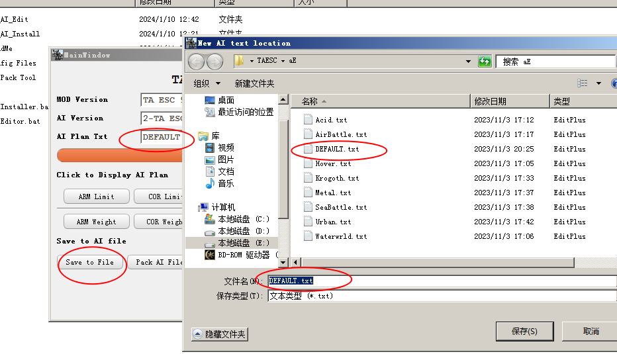

Click pack Ai file to complete the final step.

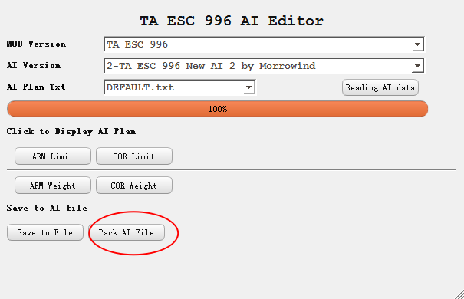

Program will auto Pack it to AI version Directory.

Packed File Name will like 0-TAESC AI.ccx

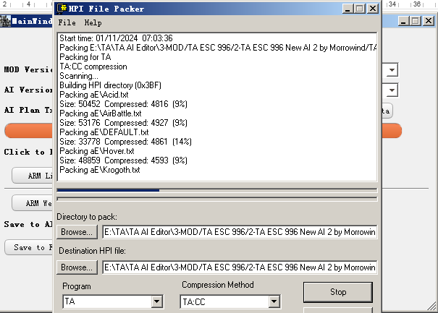

Use AI Installer to Quckly Installer

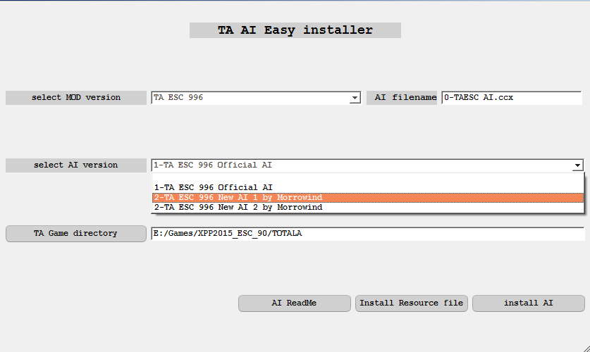

## # About the resource file

Resource file contains mod data ,examples:

TAESC TAESC.gp3

TAAC acdata.acc

TA33B ta33bn.33b

TAESC directory structure

aE - Ai

downloadsE - downloads

gamedatE - gamedata

guiE - guis

unitpicE - unitpics

unitsE - units

weaponE - weapons

TAAC and TA33B directory structure

ai

units

gamedata

So adding or modifying ESC files does not affect TAAC and TA33B

TA33B will conflict with TAAC 1.5(they are use same dirname in pack resources), please split two mod in different TA catalog. Or you can make sure there only one “MOD AI.ccx” in the game catalog.

## # ta_config.properties

**#[]Square brackets represent the beginning of each configuration node**

[Mod_dir]

**#MOD dir**

mod_dir=3-MOD

[Mod_ini]

**#The configuration file name of each MOD version**

mod_ini=ta_mod.ini

[TA_Pack]

**#HPIPack pack program**

HPIPack= 2-TA Pack Tool\HPIPack.exe

## # ta_mod.ini

**#[] Square brackets represent the beginning of each configuration node**

[TA_MOD]

**# MOD** **version**

modName=33BN

[Mod_Source]

**#Resource folder,the default is 0-ModSource,0-TAUnitPic**

SourceDir=0-ModSource

PicDir=0-TAUnitPic

[TA_Pics]

**#unit ICON**

**#The program looks for images in directory(0-TAUnitPic,AI version)**

**#when add new unit icon, put it in the AI version folder**

pic_root=0-TAUnitPic

**#taesc-unitpicE，33b-UnitPics**

Prefix_unitpicE=unitpicE

**#set 1 to cut the picture.**

**#Because the ICON in some mods are much larger**

isCrop=0

**#** **The dimensions after cutting**

corpSize=96,96

**#** **cut start at coordinate(X,Y)**

corpPositon=0,0

[TA_CanBuild_Read]

**#SIDEDATA.tdf DIR**

**#TAESC named from TAESC.gp3**

Build_Dir = TAESC

**#SIDEDATA.tdf DIR**

**#DIR: \TAESC\gamedatE\SIDEDATA.tdf**

Prefix_gamedatE = gamedatE

**#SIDEDATA.tdf** **contains AI build list information**

**#** **Note the case of the SIDEDATA.tdf file name**

Default_File_Name = SIDEDATA.tdf

[TA_Unit_Read]

**#AI txt DIR**

**#TAESC named from TAESC.gp3**

**#DIR: \TAESC\aE\**

AI_Dir = TAESC

**#AI txt DIR**

**#DIR: \TAESC\aE\**

Prefix_aE = aE

[TA_Pack]

**#Pack parameter**

**#** **Name of the packed file=TAESC AI.ufo**

**#exists in every AI version directory (AI shcema 1, AI shcema 2)**

**#0-xx.CCX will be Highest priority read in TA.EXE**

Target_file=0-TAESC AI.ccx

[TA_Levels.Side]

**#Side-Race Side,Support addition**

**#ARM-AMR CORE-COR,Refer to race data name in SIDEDATA.tdf**

Side=ARM,COR

**#Each Race needs to add a node in the format of [TA_Levels.Race].**

**#ARM Tech**

[TA_Levels.ARM]

**#How is the Technology levels**

Levels=T0,T1,T2,T3,T4

**#Technology level: The name of the factory in the game, such as the commander is ARMCOM, level 1 robot factory is ARMLAB**

T0 = ARMCOM

T1 = ARMLAB, ARMVP, ARMAP, ARMSY, ARMHP, ARMFHP, ARMPLAT

T2 = ARMALAB, ARMAVP, ARMAAP, ARMASY, ARMAHP, ARMFAHP, ARMASPEN, ARMAPLAT

T3 = ARMELAB, ARMGANT, ARMFAB, ARMESY, ARMEHP, ARMFEHP, ARMESPEN, ARMEPLAT

T4 = ARMULAB, ARMSSY

**#COR Tech**

[TA_Levels.COR]

**#How is the Technology levels**

Levels=T0,T1,T2,T3,T4

**#Technology level: The name of the factory in the game, such as the commander is CORCOM, level 1 robot factory is CORLAB**

T0 = CORCOM

T1 = CORLAB, CORVP, CORAP, CORSY, CORHP, CORFHP, CORPLAT

T2 = CORALAB, CORAVP, CORAAP, CORASY, CORAHP, CORFAHP, CORASPEN, CORAPLAT

T3 = CORGANT, COREVP, CORFAB, CORESY, COREHP, CORFEHP, CORESPEN, COREPLAT

T4 = CORULAB, CORSSY

**#AI Tutorial**

Please see this

<https://www.tauniverse.com/articles/tutorials/ai.html>

http://aicentral.tauniverse.com/armframeart.htm